ICT Project Guidance

Education Sector Provider Roles

Author:

Sky Sigal, Architect

## Description

This document provides a catalogue of the most common roles permitting the development of the system that can be used by the sector. If the system requires being evolved to accommodate a wider set of roles, the appendices lists a more complete role.

## Synopsis

Education sector providers employ a variety of principals, admin staff, teachers, and assistant teachers to teach and assess curricula learners.

## Contents

Description 1

Synopsis 1

Contents 2

Introduction 3

Objective 3

Resolution 3

Common Education Sector Roles 4

English Medium Roles 4

Learners 4

Caretakers 4

Parents 4

Trustees 4

Work staff 5

Principal 5

Associate Principal 5

Deputy Principal 5

School Administrators 5

Ako Dean 5

Community of Learning | Kāhui Ako Leader | Lead Principal 5

Librarians 5

Teacher 5

Teacher Aides 5

Assistant Teacher 5

Learning Support Teachers 6

Learning Support Coordinator 6

Special Education Needs Coordinator (SENCO) 6

Social Worker in Schools 6

Technician 6

RTLB Resource Teacher 6

School Nurse 6

School Chaplain 6

Māori Education Roles 6

Kaiako 7

Ākonga 7

Whānau 7

Appendices 8

Appendix A - Document Information 8

Images 8

Tables 8

References 8

Review Distribution 8

Audience 8

Structure 8

Diagrams 8

Terms 8

Appendices B – Extend list of Roles 9

## Introduction

Compulsory Education Sector providers vary greatly in sizes and resources, including the number of the workforce and the roles the perform.

Very small rural schools may have only one person occupying all of these common roles, from being on the board of trustees to being the principal, to performing administration and teaching.

Larger schools may employ people to do each role.

The largest schools may employ people for each role and perform a much wider set of roles.

Most schools will be somewhere in the middle, with some but not all personnel having to perform multiple roles.

## Objective

A system procured for use by workforce and learners must be capable of being configurable to be used by the roles that are common in schools, while catering for the great variety in size and hence the role distribution.

## Resolution

The first step to the stated objective is having a list of the roles to be accounted for by a system’s design.

# Common Education Sector Roles

While there are similarities in between the English and Māori medium education providers there are also differences.

Below are listed common education space roles, listed separately, by medium.

## English Medium Roles

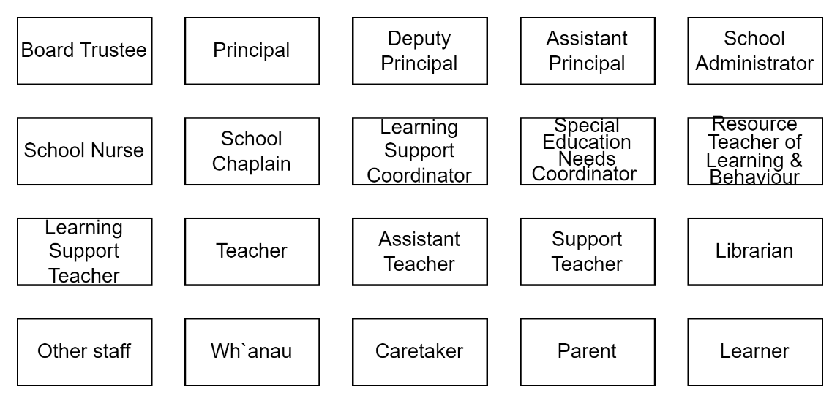

Figure : Common Education Provider Roles (HL)

#### Learners

The most important persona in the education sector is the learner themselves, who contribute to paying for their education with attention.

#### Caretakers

Learners have Caretakers, who may or may not be relatives or parents to the Learner.

Caretakers enrol Learners with education Providers of various types, governed by Board of Trustee members.

#### Parents

The default context is Parents being Caretakers of Learners, but this is not universal.   
A divorced or ex-partner may be forbidden by court from being around a Learner.

#### Trustees

A member of a school’s Board of Trustees (BoT), which have the stewardship role that involves planning for and acting in the interest of the school and its community. Student learning, wellbeing, progress and achievement are the board’s main concern.

The board of trustees is the employer of all staff, including the principal, and set the provider’s strategic direction.

#### Work staff

Is the logical group of principal, school administrators, teachers, and other staff.

#### Principal

Principal are hired by Board of Trustees to lead the whole school community, including learners, teachers, staff, parents, and community partners. They manage the administration of all work related to students, teachers and staff.

#### Associate Principal

Supports the Principal and Deputy Principals to lead and implement the school’s strategic goals, assist in leading and implementing change, and improvements in culture, relationships, communications.

#### Deputy Principal

Support the Principal in leading the management of the school.  
The position is in between Principal and Assistant Principal.

#### School Administrators

Provide the day to day administration tasks for a school.

#### Ako Dean

TLD

#### Community of Learning | Kāhui Ako Leader | Lead Principal

Provides leadership in building productive collaboration, supporting with professional expertise as needed by the Kāhui Ako’s principals and teachers to facilitate the development and implementation of the Kāhui Ako’s achievement plan,

#### Librarians

Procure, maintain, provide and grow a physical or digital collection of books, archives, learning resources, programmes, devices and library management services.

#### Teacher

Plan, prepare and present lessons, set and mark assignments and tests, assess students work to inform personal training plans.

#### Teacher Aides

TLD

#### Assistant Teacher

TLD

#### Learning Support Teachers

Identify, assess, support, monitor and evaluate students' specific learning needs, in collaboration with other members of the school community involved with students, recognising and valuing the diversity in our student population.

#### Learning Support Coordinator

The Learning Support Coordinator oversees and works collaboratively with other executive staff in the implementation of targeted intervention strategies and programs, as well as classroom support and other support for students with higher learning needs.

#### Special Education Needs Coordinator (SENCO)

A school-based coordinator for the application of funding to meet special teaching needs. Coordinates the development of individual Education Plans (IEPs) and Individual Behaviour Plans (IBPs).

#### Social Worker in Schools

SWiS are qualified, registered social workers who work alongside students and whanau to support finding solutions to challenges that may impact on children's education and well-being.

#### Technician

A science lab technician deals with hazardous chemicals, and to varying extents, with laboratory safety.

#### RTLB Resource Teacher

School based Resource Teachers of Learning and Behaviour (RTLB) support and work within schools to help students with moderate learning and/or behavioural difficulties.

#### School Nurse

Work with students, their families, school staff and secondary health services to provide youth focused Nursing care to best support students in schools. Oversee the emotional, mental, physical, and social health of students.

#### School Chaplain

Provide faith-based guidance to school community members.

## Māori Education Roles

Roles in Māori Medium schools have different names and should not be assumed to have a 1-to-1 equivalency with English Medium Roles.

#### Kaiako

: teachers and educations within a kura.

#### Ākonga

: a Learner.

#### Whānau

: the tamariki’s [extended] family.

Appendices

Appendix A - Document Information

### Images

Figure 1: Common Education Provider Roles (HL) 5

Figure 2: List of NZ Education Sector Roles 10

### Tables

### References

**There are no sources in the current document.**

### Review Distribution

The document was distributed for review as below:

|  |  |
| --- | --- |
| Identity | Notes |
| Amy Orr, Data Domain Architect |  |
| Sandy Britain, Enterprise Architect |  |
|  |  |

### Audience

The document is technical in nature, but parts are expected to be read and/or validated by a non-technical audience.

### Structure

Where possible, the document structure is guided by either ISO-* standards or best practice.

### Diagrams

Diagrams are developed for a wide audience. Unless specifically for a technical audience, where the use of industry standard diagram types (ArchiMate, UML, C4), is appropriate, diagrams are developed as simple “box & line” monochrome diagrams.

### Terms

Refer to a project’s Glossary.

Appendices B – Extend list of Roles

While this document outlines a small set of roles in the education space, sufficient for many circumstances, there are many more.

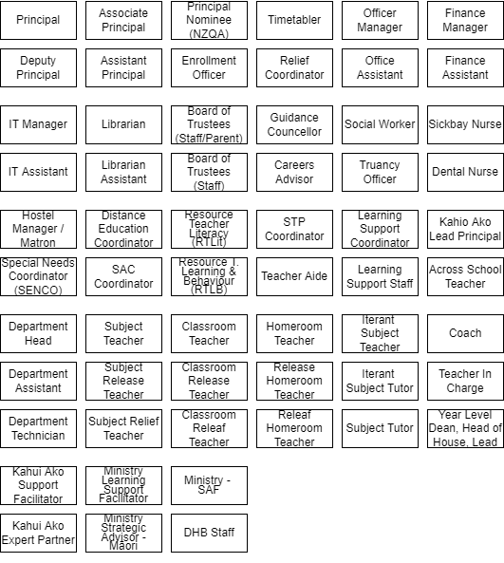

Figure : List of NZ Education Sector Roles